**SIMULATION SCRIPTS**

**PROCESS OF SIMULATION**

The simulation for this research was carried out using the CMG 2020 version. The reservoir simulation was a comprehensive process that involved several steps that were carried out to accurately model and analyze advanced recovery processes in the reservoir. The format of the simulation approach was carried out in three phases:

1. Pre-processing
2. Simulation
3. Post-processing

**Pre-Processing Phase**

This process involved the characterization of the reservoir including the geological, petrophysical, and fluid properties. In this phase, a detailed reservoir model that represents the physical characteristics of the reservoir, such as its structure, porosity, permeability, and fluid properties was achieved. For the pre-processing, the Builder and WinProp were used for this phase.

**Simulation Phase**

This process involved the simulation and creation of the field-scale production pattern and wellbore modeling, which was done using CMG GEM (Generalized Equation-of-State Model). CMG GEM is a comprehensive reservoir simulator specializing in compositional, chemical, and unconventional reservoir modeling, catering to various reservoirs and recovery processes. Additionally, the software enables accurate modeling of carbon capture and storage projects by simulating the long-term effects of CO2 injection into geological formations or saline aquifers.

**Post-Processing Phase**

In this process, CMG Results was used to deliver visualization and analysis of the simulation results and interpret it to gain insights into the reservoir behavior, evaluate the recovery strategies, and optimize production.

**SIMULATION FORMAT**

1. **Grid Construction**: A computational grid was constructed to discretize the reservoir volume. The grid divided the reservoir into small cells or blocks, allowing for the numerical simulation of fluid flow and other physical processes. The physical model of the reservoir was built using the CMG Builder. From the builder, the simulator, working units, porosity and grid type (GEM, Field and Single Porosity, Cartesian) were defined respectively as well as the simulation start date (1990/1/1). For this project, the reservoir model consisted of 50 blocks in both the x and y directions and 6 blocks in the z direction having a total of 15,000 grid cells.
2. **Reservoir Fluid Modeling and Characterization**: The reservoir fluid model was characterized using WinProp and this is the overview of the process of the fluid modelling using CMG WinProp:
3. **Selection of Equation of State**: The first thing carried out when working with the CMG WinProp was the selection of the name of the model, the equation of state to be used to match the laboratory data and represent fluid behavior, and lastly, the unit and feed (Peng Robinson 1978, Psia & deg F, and mole) of the basis of the model were defined respectively.
4. **Component, Property Selection and Composition of Reservoir Fluid**: This involved describing and inputting the reservoir properties, and individual percentage composition of hydrocarbon components.

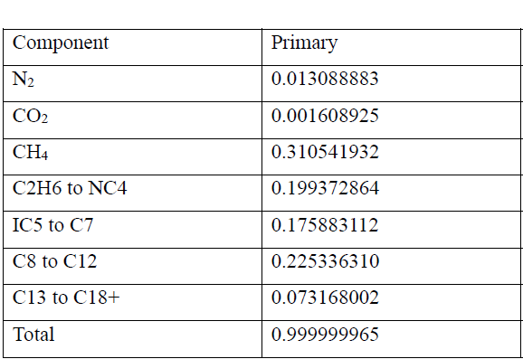

1. **Separator Conditions of Fluid Model**: In this section, the separator conditions of the fluid model were inputted. This included parameters like pressure, temperature, gas oil ratio, formation volume factor, API, specific gravity and density at reservoir condition, stock tank, and separator conditions
2. **Property regression**: After inputting the separator conditions, regression analysis was performed on the composition and reservoir properties to match laboratory data with simulation data. WinProp provides automatic parameter selection and built-in parameter bounds to simplify the process of matching lab results. This step ensured the accurate characterization of fluid composition and properties. We regressed the heavier hydrocarbon components which were C8 to C12 and C13 to C18+.
3. **Model Validation and CMG GEM model creation**: When the regression was complete and all other parameters were inputted, the WinProp fluid model was run and validation was checked. After that, a simulation model is created with CMG GEM in order to be able to import and load the fluid into the CMG Builder.
4. **Fluid Model Initialization**: The WinProp fluid model was imported into Builder and the reservoir model needed to be initialized with initial conditions before running the simulation. The values of the mole fractions of the hydrocarbon components as well as initial fluid saturation, pressure, and temperature distribution of the reservoir were also inputted which was the same as the values inputted into WinProp. For the model created, the initial reservoir pressure was 2090 psia while the initial temperature was set to 186 F.
5. **Wellbore Modeling**: This process allowed for the simulation of complex well completions, including different types of wellbores, well trajectories, and completions. Wellbore interactions, such as heat transfer, fluid flow, and pressure drop, were also captured in the simulation. Furthermore, five wells were utilized in the simulation to create a field-scale inverted five-spot patterned model while incorporating the core flood history match. Four of the wells were producers (Producer 1, Producer 2, Producer 3, and Producer 4) that produced throughout the life of the field, and one injection well started injection after some time when production started before running the simulation.
6. **Solver and Parallelization**: CMG utilizes advanced solver and parallelization that helped in optimizing the simulation efficiency, and enable the running of multiple simulation jobs simultaneously.
7. **Advanced Recovery Process Simulation**: In the recovery process simulation, the CO2-WAG was used in order to control mobility as the water helps to displace the CO2 and oil banks. The CO2-WAG process was modeled as a cyclic alternation of water and CO2 with the injection well configured in a central location to achieve an optimized sweep efficiency while optimizing the production strategies and this injection cycle started in the year 2000.
8. **Analysis and Interpretation**: Once the simulation was completed, the results were analyzed and interpreted to gain insights into the reservoir behavior, evaluate the recovery strategies, and optimize production. CMG Results was used to provide visualization and analysis tools to explore the simulation results, including production rates, pressure distributions, and oil recovery amongst others. The simulation dataset at the end of the analyses was used as the input for training and testing the deep-learning model.

**Appendix**

1. How to build a CO2 sequestration model: <https://www.youtube.com/playlist?list=PLrK-CCCkqvij_XyglUmTm5cd07i8Sg1xQ>
2. CMG GEM: Compositional and Unconventional Simulator: <https://www.youtube.com/playlist?list=PLrK-CCCkqvihpnSHmR33DIBGq5LRQOUPA>
3. More information on how to use the CMG software can be found on their YouTube channel and software handbook.